16 – BIT ADDITION

# EXP NO:05

# AIM:

# To write an assembly language program to implement 16-Bit Addition using 8086 processor.

# ALGORITHM:

1. Start the program by loading the first data into accumulator.
2. Move the data to a register.
3. Get the seconds data and load it into the accumulator.
4. Add the two register contents.
5. Check for carry.
6. Store the value of sum and carry in the memory location.
7. Halt.

# PROGRAM:

LHLD 8500

XCHG

LHLD 8502

DAD D

SHLD 8504

HLT

# INPUT:

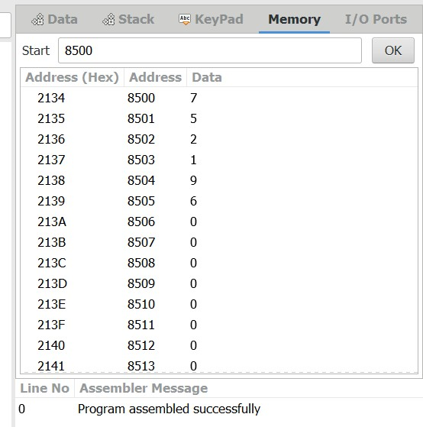

# OUTPUT:

# RESULT:

Thus the program was executed successfully using 8086 processor stimulator.